Forename: Surname:

Title of entry:

Note to entrants:
Yonkoma manga is a type of comic strip that is often used by aspiring manga artists to hone their storytelling skills. The word yonkoma translates as ‘four panels’ and refers to the vertical structure of equal-sized panels read from top to bottom. Please feel free to use the template above, or draw your own panels. But remember, the story should read from TOP to BOTTOM.
The idea of using panels in comics came from American and European influences but the narrative arch of yonkoma uses the Asian storytelling structure of ki shō ten ketsu. Entrants are encouraged to try to follow this structure in their stories! Please see below for an example.

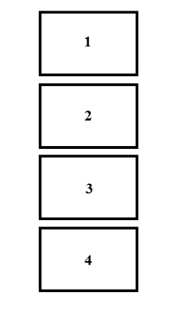 | 起(Ki) The first panel introduces the story to the reader.  承 (Shō): The second panel develops upon the foundation of the story laid down in the first panel.  転 (Ten): A new or unforeseen development typically occurs here.  結 (Ketsu): The conclusion is outlined in the final panel, showing the effects of the third panel.

