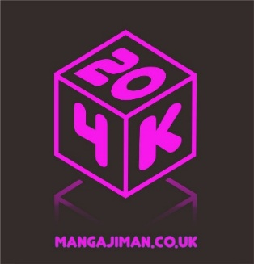 | YONKOMA YOUTH (ages 11-13)  2026 OFFICIAL ENTRY FORM  PLEASE COMPLETE THE ENTRY FORM IN BLACK INK USING BLOCK CAPITALS.
 | Title: |  | Forename: |  |  | Surname:
Postal Address (including Postcode):
Daytime / mobile telephone number:
Email:
Social media accounts (if any):
Title of yonkoma entry:
What is your reference to the theme ‘20’ in this yonkoma?
Date of Birth (DD / MM / YYYY):
Nationality:
Signature of entrant:*
Name of parent/guardian:
Signature of parent/guardian: *
Relationship of parent/guardian to entrant:
Postal address of parent/guardian:
Daytime telephone number of parent/guardian:
Mobile telephone number of parent/guardian:
Email:

*I accept the terms and conditions of the YONKOMA MANGA COMPETITION – RULES & REGULATIONS
For queries and further details, please contact: YONKOMA JIMAN COMPETITION 2026, Embassy of Japan, 101-104 Piccadilly, London W1J 7JT [t] 020 7465 6500 [e] manga@ld.mofa.go.jp [w] www.uk.emb-japan.go.jp

